To identify and use relative clauses.

Task 1. Identify the relative clauses in each of these sentences by copying only the relative clause out into your book:

Jim, who was an overweight whale, bumped his head on an oil tanker as he swam.

The villain marched across the crater that had once been a playing-field full of flowers.

The police officer called to his partner, who ignored him and continued to eat his doughnut.

I’m looking for a minion that can use Word 2010.

The man, who lives next door to me, might be a werewolf.

Task 2. Match the correct (embedded) relative clause with the sentence start and sentence end it could go with and write them into your book.

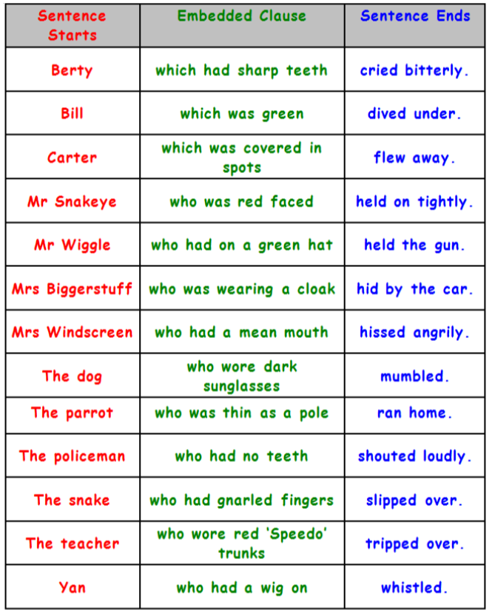

Task 3. Using the pictures below, write some sentences which include relative clauses in different positions (at the end of the sentence as well as embedded into the middle of one).

Relative Pronouns: who, whom, whose, that or which



