Year 5 Always Toolkit
- A and an
- Capital letters, full stops
- Punctuate sentences appropriately
- Joins for handwriting
- CEW words spelt correctly
- Gem Words
Year 5 Always Toolkit
- A and an
- Capital letters, full stops
- Punctuate sentences appropriately
- Joins for handwriting
- CEW words spelt correctly
- Gem words
Figurative language features
- Personification
- Alliteration
- Metaphor
- Simile
- Onomatopoeia
- Powerful adjectives
Inspiration/Ideas
- Scenic views
- Country or place
- Nature
- Animals
- Comedy, spooky, thriller…
- Emotion

Opening paragraph statements
- This explanation will…
- This explanation is intended to…
- This explanation is designed to…
Scientific Vocabulary
- Gear
- Pulley
- Lever
- Wheel
- Generator
- Electricity
- Cog
Features for an explanation text
- Cohesive devices
- Time adverbials
- Cause and effect conjunctions (as a result, this causes, consequently)
- Parenthesis (brackets)
- Relative clauses
- Powerful adjectives, scientific vocabulary
- Mechanism
- Clockwise
- Anti-clockwise
- Metal handle
- Gravity
- Push/pull

Activity 2- Explanation text
Write an explanation text. Can you invent a machine that helps you to wash your hands and explain how it works? You can be as creative as possible.

Activity 1-Poetry
Write a poetry piece based around anything of your choice and include as many figurative language features as possible. If you are stuck on ideas, look around you; remember every object tells a story…

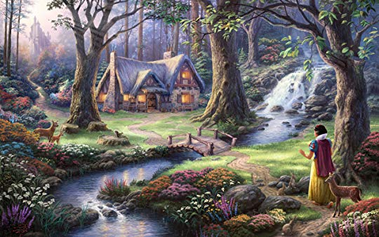
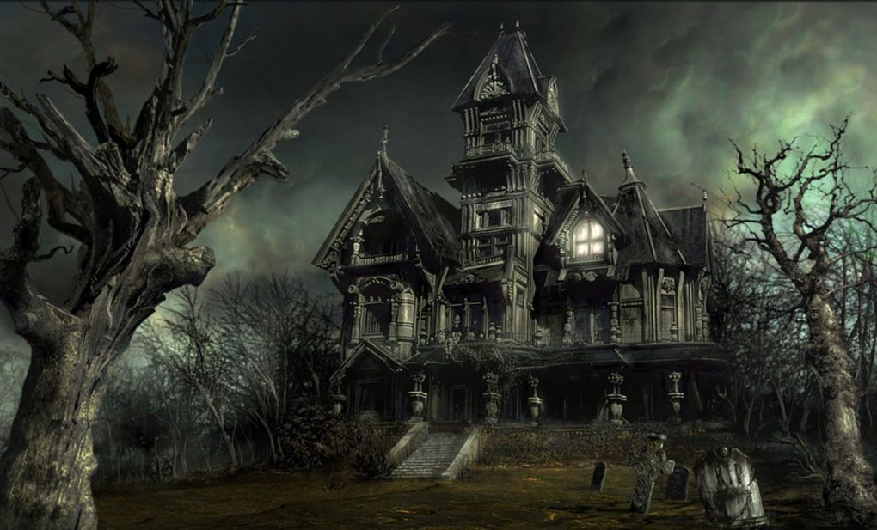


Year 5 Always Toolkit
- A and an
- Capital letters, full stops
- Punctuate sentences appropriately
- Joins for handwriting
- CEW words spelt correctly
- Gem words
Success Criteria for a setting description
- Introduction
- Paragraphs
- Describe using senses (hear, touch, smell, see, taste)
- Describe the atmosphere and mood using powerful adjectives
- Use figurative language to create effect (personification, alliteration)
- Relative clauses
Activity 3- Setting description
Choose one of the images below, or any of your own, and write a setting description. Remember to keep referring back to the success criteria.

Year 5 Always Toolkit
- A and an
- Capital letters, full stops
- Punctuate sentences appropriately
- Joins for handwriting
- CEW words spelt correctly
Language features for a suspense story
- Empty words
- Short sentences
- Rhetorical questions
- Describing character and atmosphere
- Paragraphs
- Figurative language (onomatopoeia)
Activity 4- Suspense story
Write a suspense story of your choice. Remember to make it as scary as possible! Try to use as many language features as possible.

