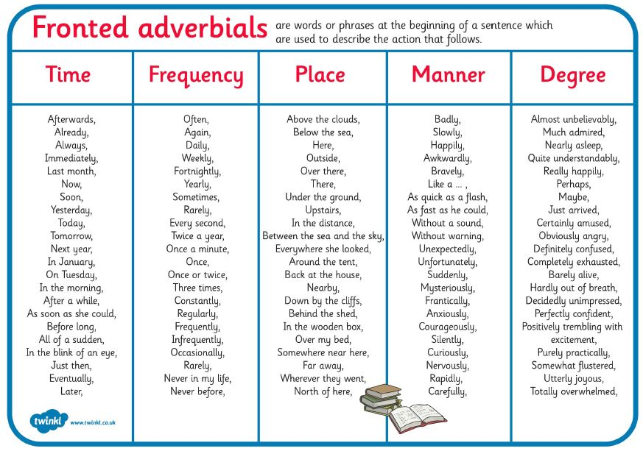
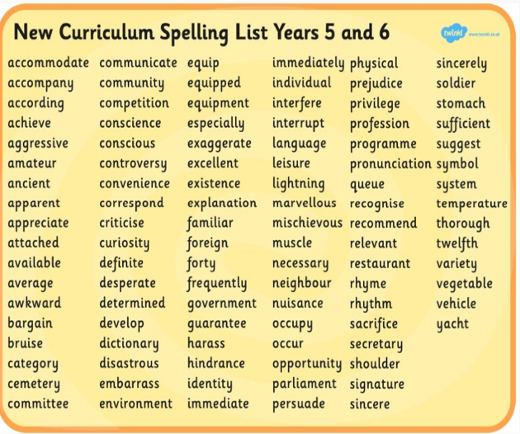

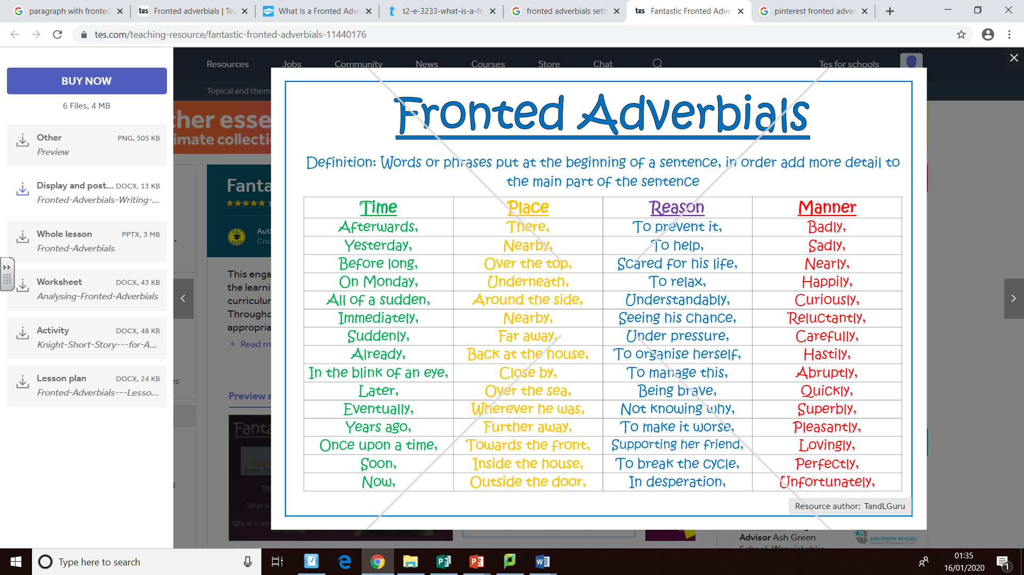
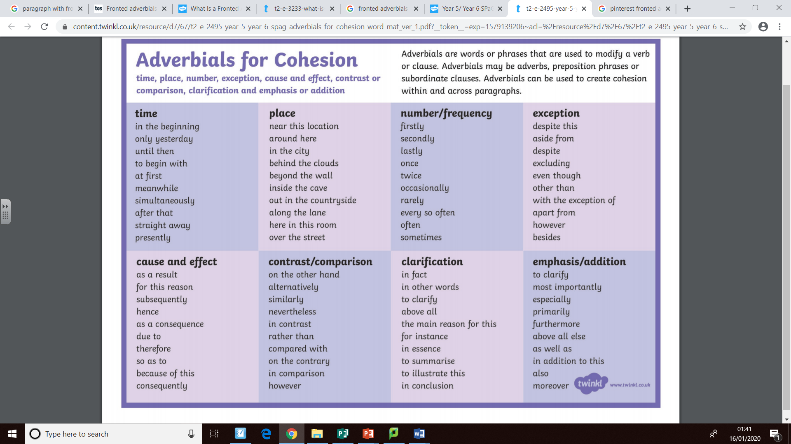
Fronted Adverbials word mat

Scrupulous (Careful, attentive to detail)
Infallible (never failing)
Unequivocal (leaving no doubt)
Palpable
Reputable
Ingenious
Copious (amount, quantity)
Wondrous
Striking

Positive Vocabulary Word Bank
Commendable
Marvellous
Precious
Stupendous
Superb
Exceptional
Stunning
Majestic
Alluring
Glorious
Sensational
Astonishing
Incredible
Miraculous
Phenomenal
Stunning
Spectacular
Astounding
Breathtaking
Prominent (important, famous)
Powerful
Supreme
Energetic
Convincing
Engaging
Timeless
Prevailing
Staggering
Prodigious (remarkable or impressively great)
Fantastic
Tremendous
Grand
Colossal

Nauseating
Repellent
Squalid (dirty unpleasant place)
Corrupt
Inferior
Delinquent
Tacky
Appalling
Dire (serious or urgent)
Disagreeable
Poisonous
Abandoned
Mischievous
Obscene
Churlish
Miserly
Oafish (Rough or clumsy behaviour)

Horrendous
Hostile
Horrific
Disgraceful
Needless
Overwhelmed
Meaninglessness
Desperation
Fearfully
Despicable (deserving hatred)
Beastly
Contemptible
Degrading
Loathsome
Infamous
Wretched
Sordid (dishonourable actions and motive)
Pitiful
Shameful
Vile
Isolated
Obnoxious
Rotten
Revolting
Worthless
Hideous
Repugnant (unacceptable)
Feckless (irresponsible)
Filthy
Notorious
Vicious

Negative Vocabulary Word Bank (Emotions)



